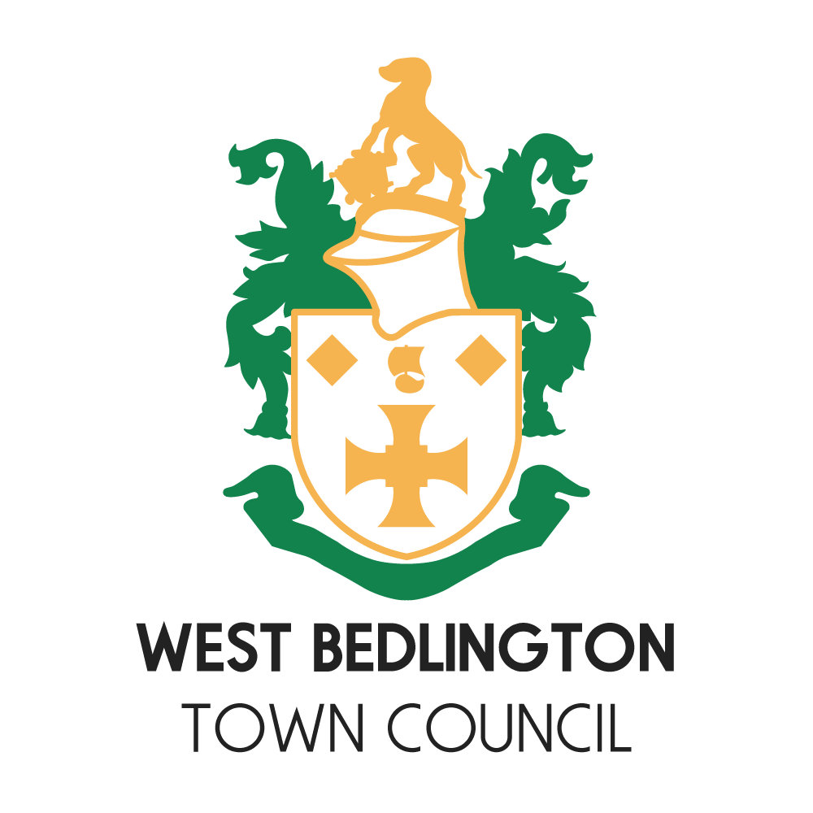

Memorial Plaques On Public Seating

|  |  |
| --- | --- |
| **Approved Minute Ref** |  |
| **Date** | **12th Nov 2020** |
| **Version** | **1** |
| **Reviewed** | **14th Dec 2024** |

**Memorial Plaques on Public Seats Owned by West Bedlington Town Council.**

West Bedlington Town Council recognises the wish for memorial plaques in public spaces. The Parish Council

will consider requests on an individual basis. The policy relates to any public seat owned by West Bedlington Town Council.

This policy has been produced with the following guiding principles:

• To be respectful and sympathetic to those seeking to install a memorial

• To ensure the use of public seating is not compromised and ensure the quality of their appearance is maintained.

**Terms and Conditions**

* Advance permission to have a memorial plaque placed on any public seat in the ownership of West Bedlington Town Council must be obtained in writing from The Council. The Council reserves the right to remove plaques that have been placed on seats without permission.
* Requests to place a plaque on a public seat must be in writing (e email will be accepted) to the Council.
* The Town Council does not accept applications for memorials for pets,
* The Town Council reserves the right to limit, in both location and number, plaques in any one area. No more than 3 (three) memorial plaques will be allowed on any one public seat.
* The cost of the plaque must be met by the applicant.
* Plaques must be brass and limited in size to 175mm wide by 75mm high. The inscription on the plaque is to be restricted to “In the Memory of” the name of the person, recognition of public office (if appropriate) and the dates of birth and death.
* The applicant will be responsible for delivering the memorial plaque to the Council Office.
* The Council will install the plaque on the seat at no cost to the applicant.
* No additional mementos such as flowers, statues or vases will be permitted alongside or placed on any bench. The Town Council reserves the right to remove any such mementos or flowers
* The Town Council’s standards of maintenance will be accepted as keeping the bench fit for purpose and clean. This will involve occasionally removing algae and grime and repairing minor faults within the resources of the Council.
* The Parish Council is not responsible for the maintenance of memorial plaques.
* Memorial plaques must not be removed, or inscriptions amended without the written approval of the Town Council.
* The Town Council will undertake regular assessment of all benches and reserves the right to remove any bench that is no longer considered safe and fit for purpose. In this event, the named person(s) on the enquiry form will be informed. The donor will be asked to collect the inscribed plaque within 4 weeks. If contact cannot be made plaques will also be disposed of within 8 weeks.
* The Parish Council retains the right to re-site a plaque should this become necessary.
* The Parish Council accepts no liability for damage to benches or plaques by a third party.
* The Parish Council will keep a record of donors and their contact details in accordance with the General Data Protection Regulations. It is the responsibility of the donor to provide the Clerk with updated details in writing. Failure to do so could lead plaques being removed without notice to the donor.