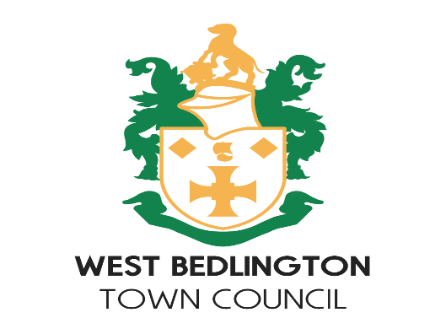

**Provision of a Grit Bin**

**Procedure**

**West Bedlington Town Council**

|  |  |
| --- | --- |
| **Approved Minute Ref** | **S15/13** |
| **Date** | **13 Jan 2013** |
| **Version** | **1** |
| **Review Minute Ref** | **21/161** |
| **Review Date** | **12th Dec 2024** |
| **Next Review Due** | **12th Dec 2027** |

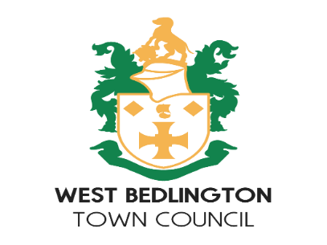

**Provision of a Grit Bin by West Bedlington Town Council**

**Stage 1**

Ask the applicant to apply to NCC in the first instance.

If successful refilling costs will be met by NCC in perpetuity.

If unsuccessful apply to West Bedlington Town Council.

NCC have agreed to send West Bedlington Town Council copies of the unsuccessful application.

**Stage 2**

Review scoring from NCC and see why unsuccessful.

Discuss at the Services Committee the reason for the application and why it was turned down.

Ask for advice from NCC as appropriate

Make a decision as appropriate

Another method available is to ask the Ward County Councillor to use their small schemes allowance.

**Costs**

**Town Council provides bin**

A grit bin costs £200 and needs to be sited by NCC.

This cost includes an initial refill then 2 further refills.

Additional refills cost £100 for 3 refills which the Town Council is expected to pay in perpetuity for refills.

**County Councillor provides bin**

A County Councillor can pay £200 out of his/her small schemes allowance which can buy a bin and 2 further refills.

The Town Council is then committed to purchasing additional refills at £100 for 3 in perpetuity.